Kripa

Marine SL Inventory/ Invoicing System

USER GUIDE

Table of Contents
Starting Application: 3
Stopping Application: 3
DB Backups: 3
Updating Application: 4

Starting Application:
The application will start by itself as you will start the machine but in case for some reason its down and you want to start it run file:
d:/software_application/Kripa_Documents/manualbackup.bat
this will start the application server. Following window will appear on your machine do not close it:

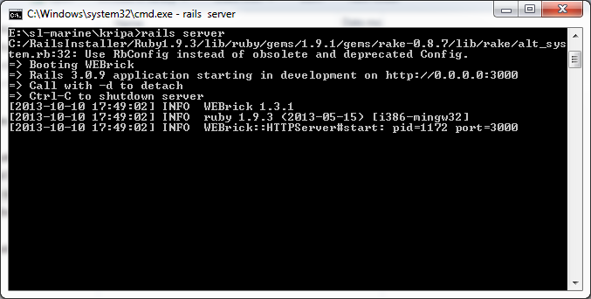

Stopping Application:
To stop running application just bring up the window in figure above and Press Ctrl+C.

DB Backups:

DB backups are important to ensure that we do not loose important data in any case. DB backups can be taken in 2 ways:

- Automatic DB backups:
Automatic DB backups are scheduled to run every evening. They will take dump of entire database and dump it at location:
d:/software_application/db_backups
The name of the dump file will be:
ddmmyyyy_auto_database.dump
where ddmmyyyy is the date on which database dump is taken.

- Manual DB Backups:
To take manual DB backup just run file:
d:/software_application/Kripa_Documents/manualbackup.bat
This will create DB dump file at same location as automatic DB dumps with name:
ddmmyyyy_manual_database.dump

Updating Application:

To update application with the latest code just run the file mentioned below. It will pull latest code from Internet Repository and update the application.
d:/software_application/Kripa_Documents/manualbackup.bat

